Step 1 Create Logic App send-event

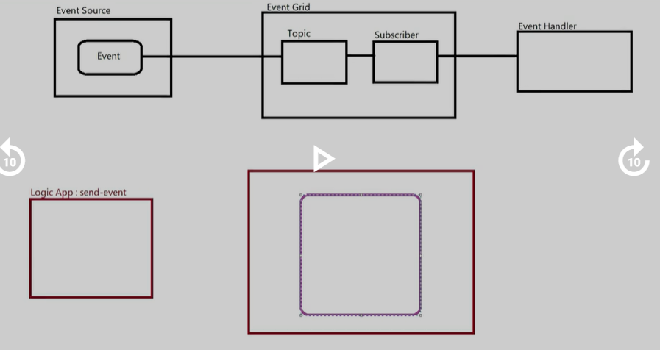

2

Create Event Grid